## Setting up pycharm project

File 🡪 new project 🡪 paste the path into which you cloned the files

Choose "use existing…"

## Setting up python dependencies from pycharm

File 🡪 settings 🡪 project interpreter 🡪 gear icon 🡪 Add interpreter 🡪 New virtualenv

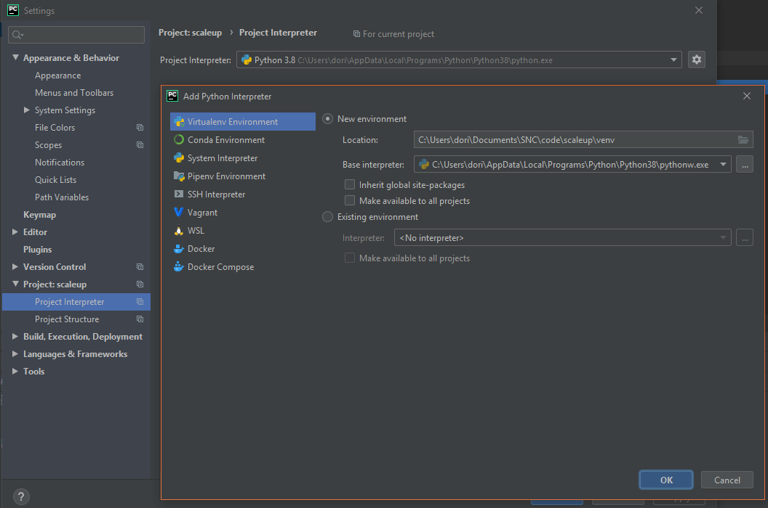

Once installation is done, be sure to set this interpreter as your default.

You need to add packages. Click on the + sign in the back window (1), and you'll have the front window opened. You can search for the name of the package (2), then click Install (3)

Note I had the import error about PIL, which is solved this way (you can see it behind the windows)

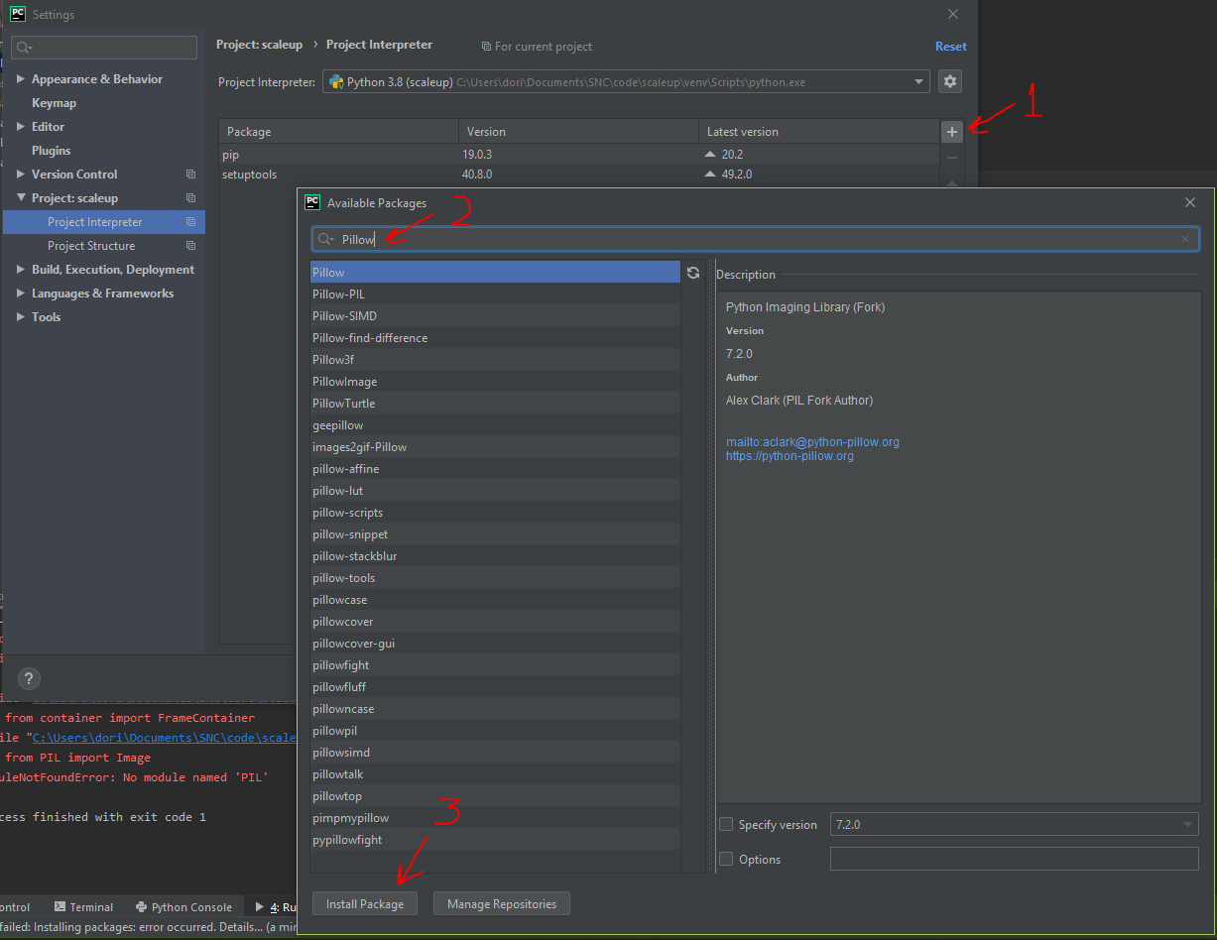

If you run into an error installing Pillow, you may have an issue with the pip, so apply and Ok all those windows, then open the CMD window, CD to your project's dir, and activate the venv

For me it was on

cd C:\Users\dori\Documents\SNC\code\scaleup\venv\Scripts\

activate

Then force-reinstall pip using this:

python -m pip install -U --force-reinstall pip

You can also install packages from command line using:

python -m pip install --upgrade Pillow

To run the framework, you will need to create a configuration and also make sure you're using the right interpreter on that like so:

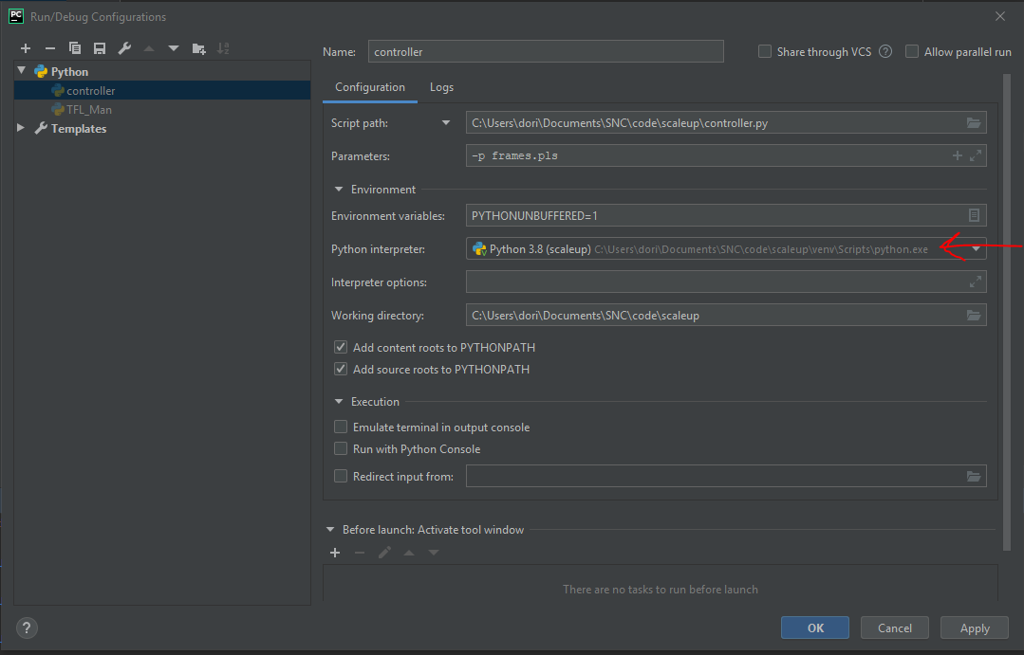

You should also make sure to install numpy, scipy, matplotlib,

Pycharm may need to think a bit after you install packages.